

**University of Asia Pacific**

**Course Code: CSE 212**

L**ab Project:Hostel Database Management system**

**Submitted by:**

**Md.Mahamudul Hasan**

**Md.Mahamudul Hasan Khan**

**Registration No. – 17101062,17101065**

**Roll – 062,065**

**Section – B1**

**Submitted to:**

**Nadeem Ahmed**

**Date of Submission: 28- 1- 2019**

**Index**

|  |  |
| --- | --- |
| **Number** | **Subject** |
| **1.** | **Project Scenario** |
| **2.** | **Schema daigram** |
| **3.** | **E-R diagram** |
| **4.** | **Queries and output** |
| **5.** | **Appendix** |

1. **Project Scenario:**

The basic purpose of designing this project is to get rid from manual entry and record system and try to give easy and simple database management system for hostels.

This project is designed to keep the record of the students living in hostel, allocation of rooms, their monthly cost dues and many more things but we are trying to make this management system as much as simple and easy as we can, but we well try to cover all the basic elements use for hostel management database.

Staff

2.Schema Diagram:

Hostel

Manager

Complain

Furniture

Rooms

Food items

Visitor

Fee

Employee

student

Boys Hostel

3.E-R Diagram:

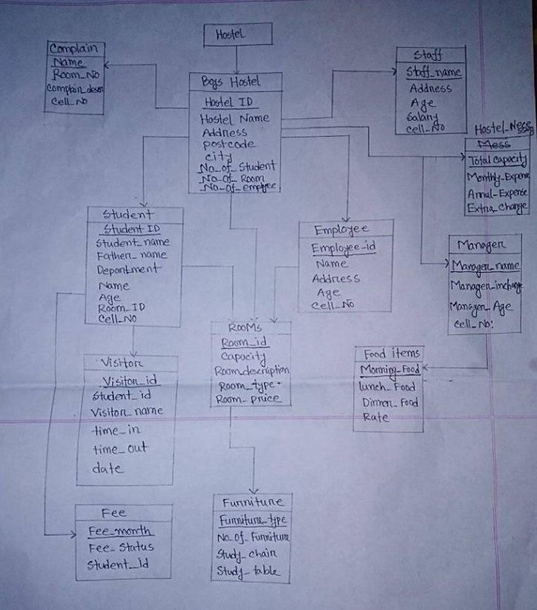

4.Queries and Output:

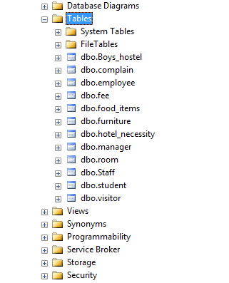

i).Output:Table-Boys_hostel

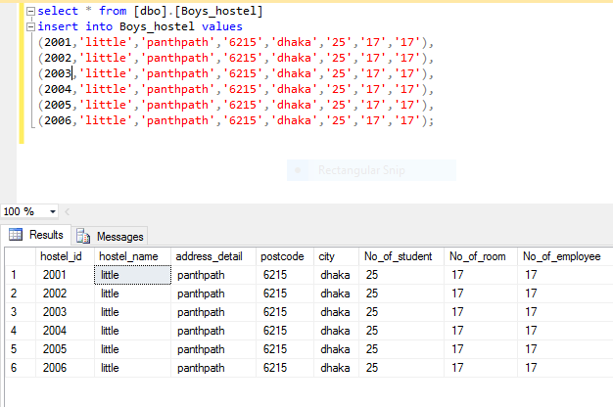

ii).Output:Table-Student

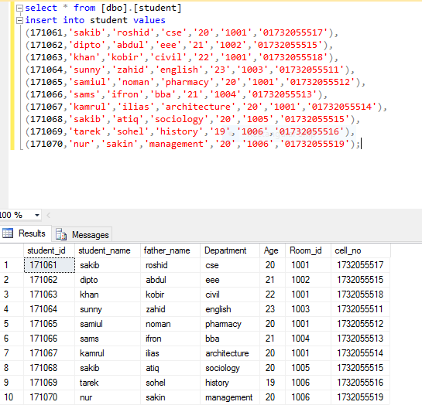

iii).Output:Table-Employee

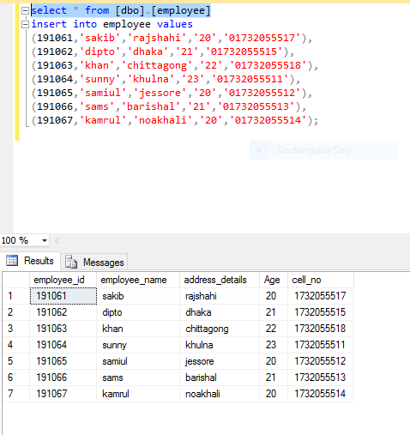

iv).Output:Table-Rooms

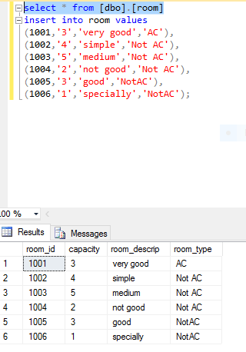

v).Output:Table-Visitor

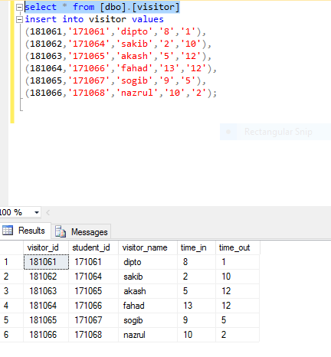

vi)Output:Table-Staff

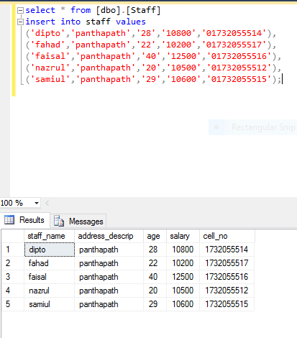

vii)Output:Table-Manager

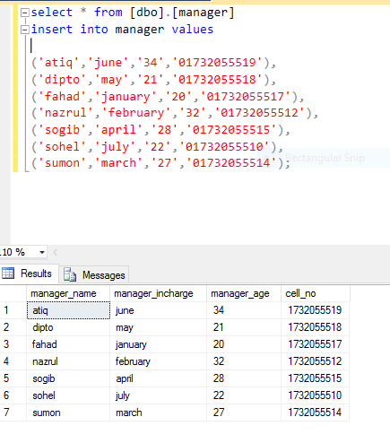

viii).Output:Table-Hostel_Necessity

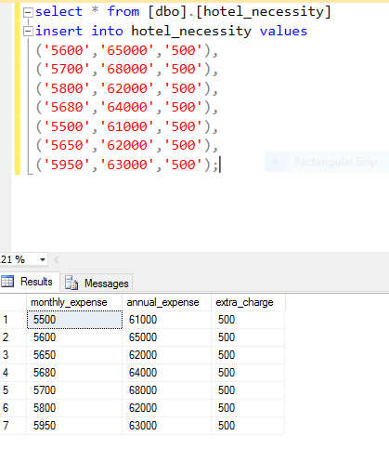

ix).Output:Table-Furniture

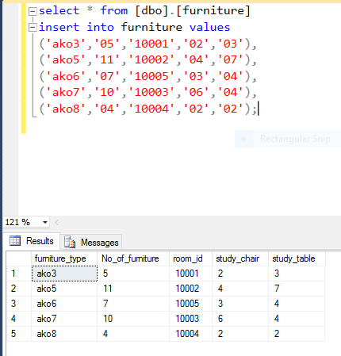

x)Output:Table-Complain

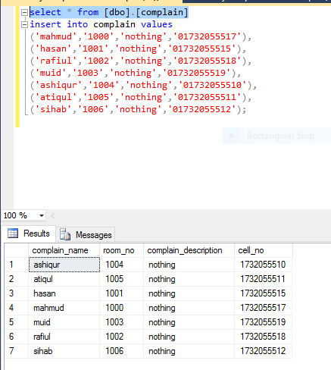

xi)Output:Table-Fees

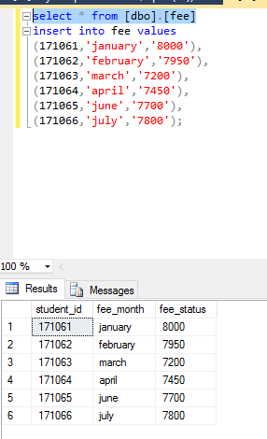

xii)Output:Table-Foods

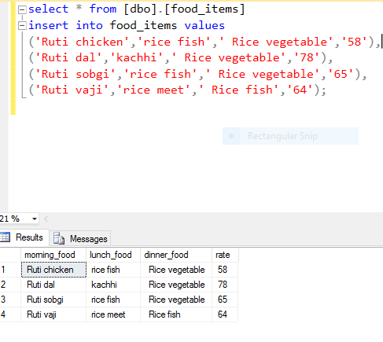

5.Appendix:

i)Boys_Hostel:

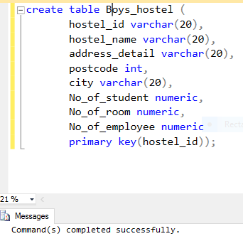

ii)Student:

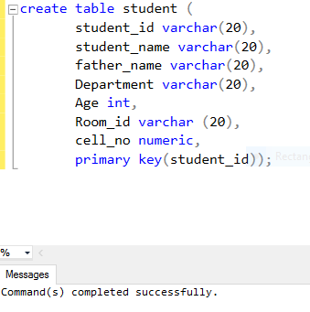

iii)Employee:

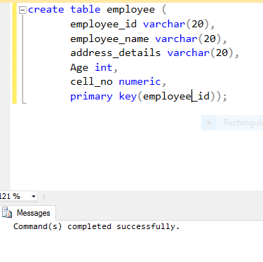

iv)Rooms:

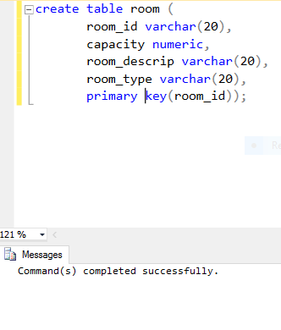

v)visitor:

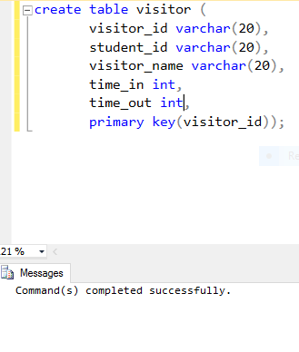

vi)Complain:

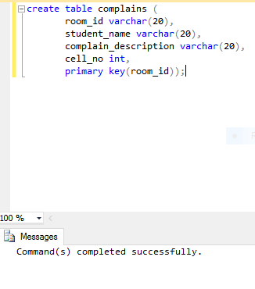

vii)Fee:

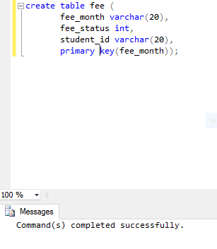

viii)Food:

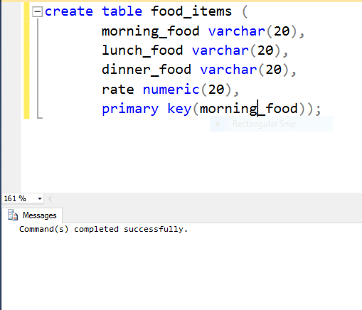

ix)Furniture:

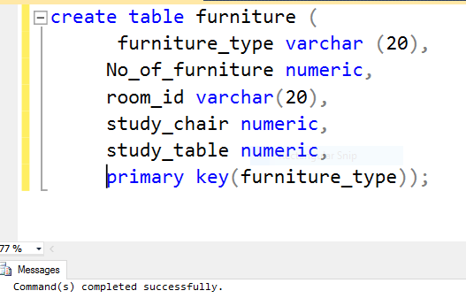

x)Hostel Necessity:

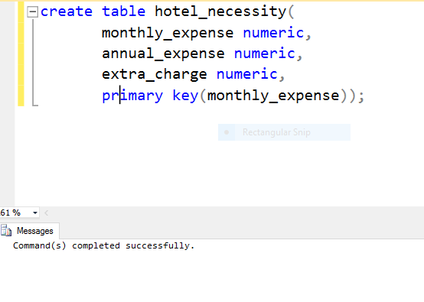

xi)Manager:

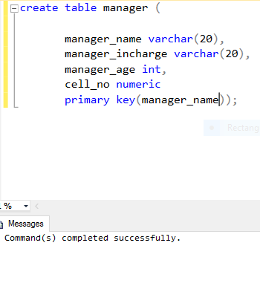

xii)Staff:

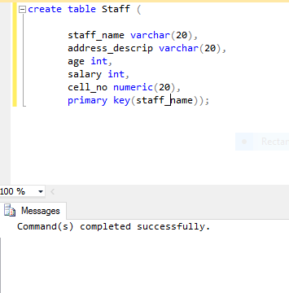

------ Allah Hafez -------